1. 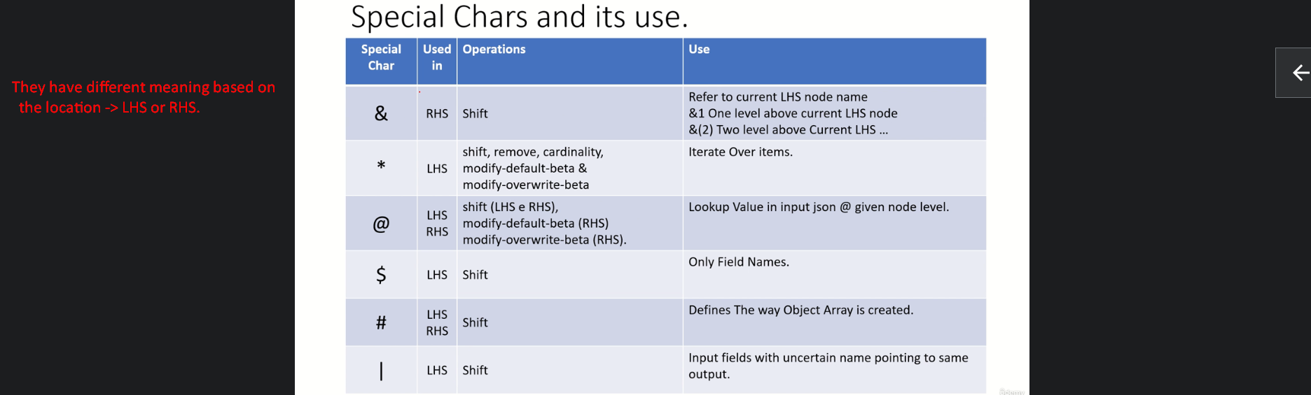
2. JOLT Pointer points the current location.
3. The following will be our **INPUT JSON**.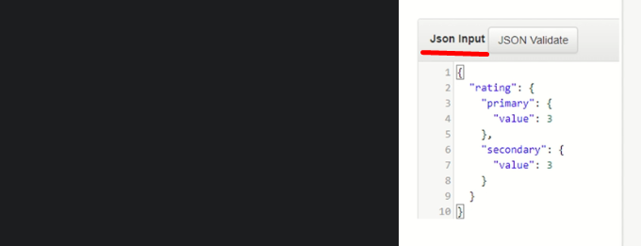

Let’s discuss Ampersand &

1. To refer a node name rather than value.  
   By default current node name but we can do any level up too.  
   We will see how?
2.   
   
3. 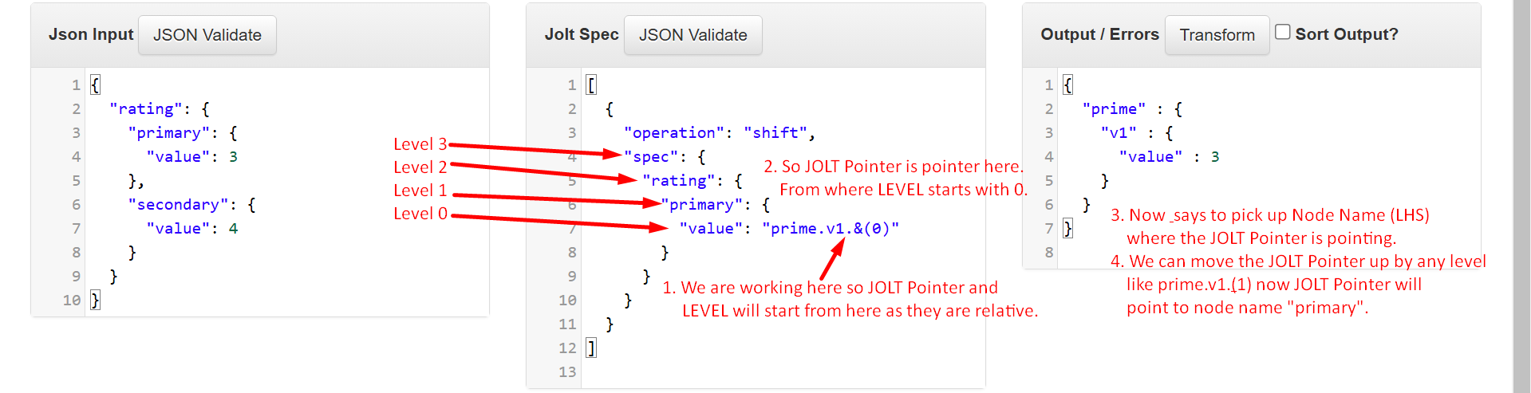  
     
   We can use just & instead of &(0) in case to refer to the current node.  
   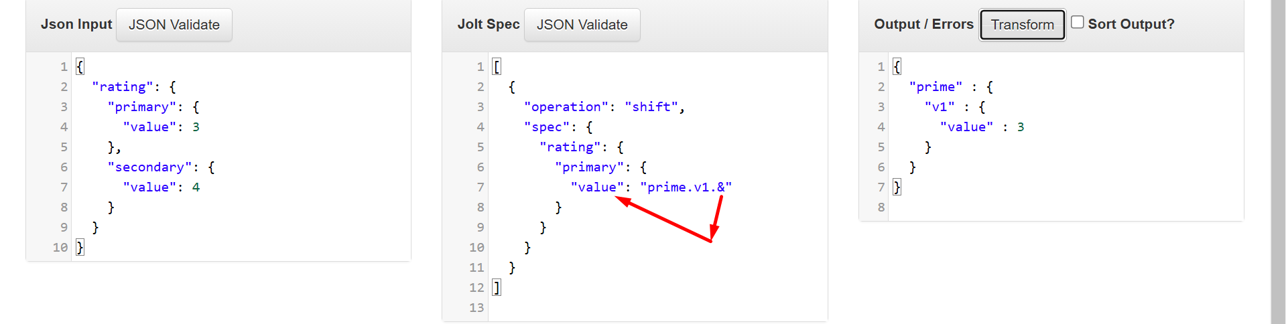
4. JOLT Pointer One Level Up.   
     
   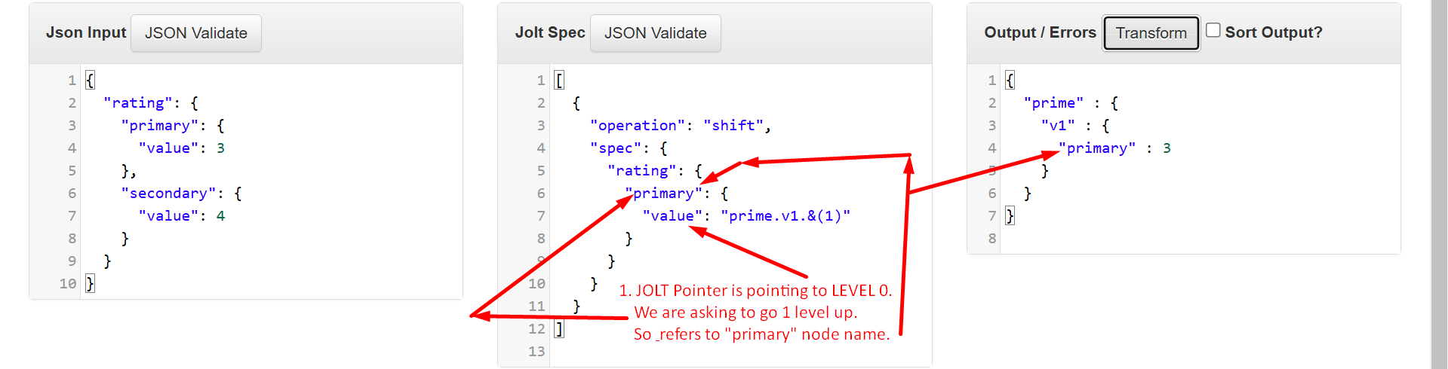
5. 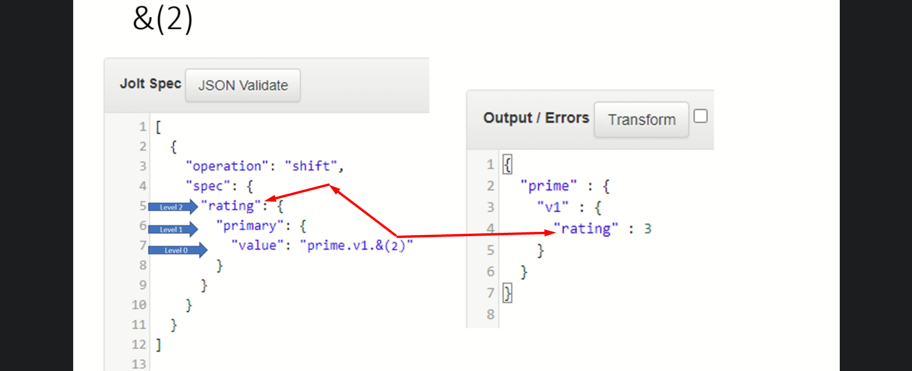
6. 